A **RIGHT JOIN** in SQL is used to combine rows from two tables based on a related column, returning all rows from the **right table** (in this case, Course), and the matching rows from the **left table** (Student). If there is no match, NULL values are returned for columns from the left table.

Here’s an example involving Student and Course tables:

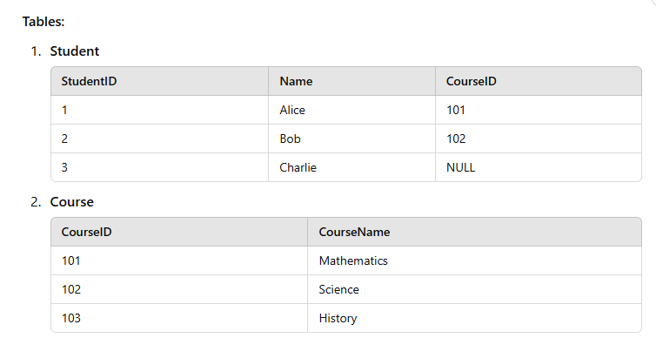

Right join

SELECT Student.StudentID, Student.Name, Course.CourseID, Course.CourseName

FROM Student

RIGHT JOIN Course

ON Student.CourseID = Course.CourseID;

